Press Release

Mazzoleni at Art Basel
Piero Manzoni. Achromes: Linea Infinita
15 – 18 June 2017
Booth C8

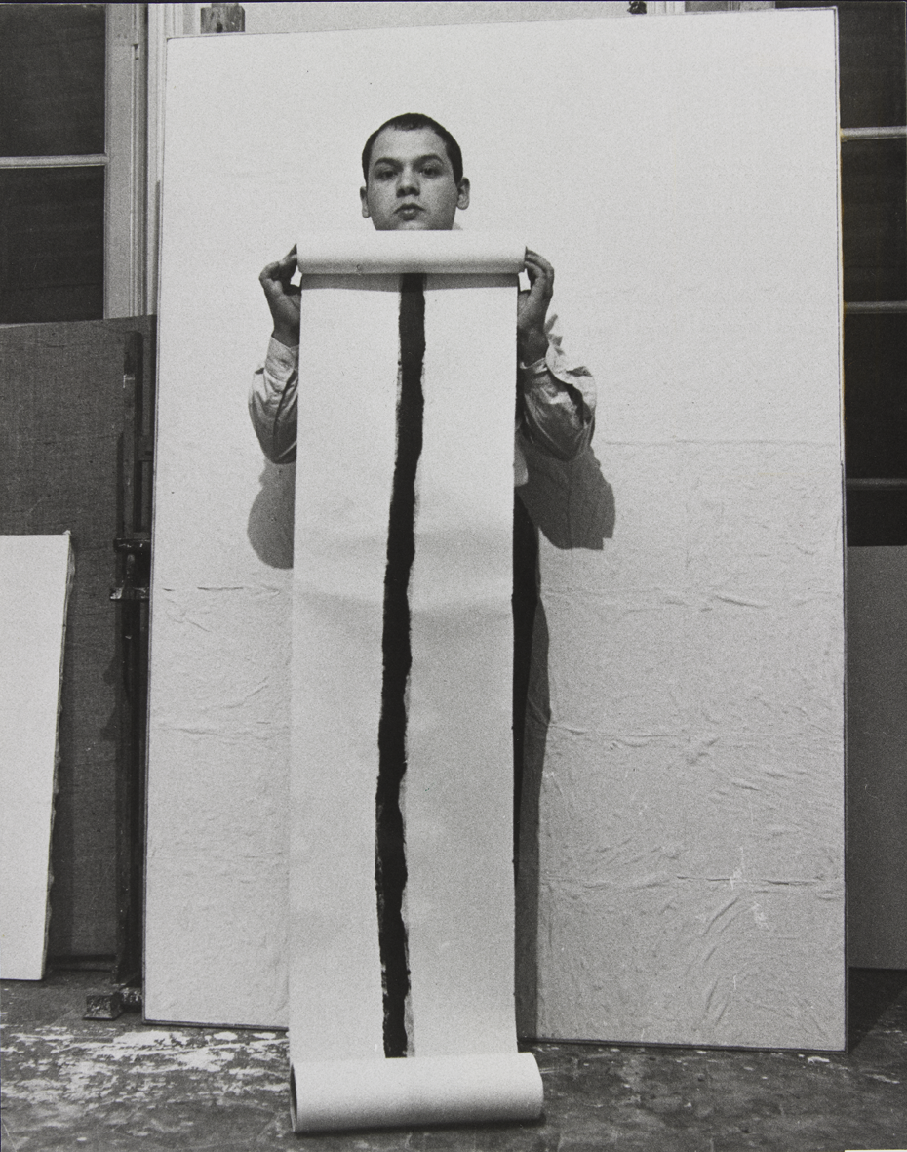
Mazzoleni is pleased to announce its participation in Art Basel’s European edition for the first time this June with a solo presentation of Piero Manzoni (1933–1963) in the Feature sector of the fair.

Manzoni is widely considered one of the most influential artists of the 20th century. Known for his ironic and playful methodology, he radically transformed the artistic language of European art and developed a lasting reputation for prefiguring the Conceptual Art movement, among others.

This exhibition will show examples from two of the artist’s most well known series of works, the Achromes (1957–1963) and the Linee (1959–1963). It follows the gallery’s acclaimed 2016 exhibition of the artist at its London space, ‘PIERO MANZONI Achromes: Linea Infinita’, which was the first exhibition to focus uniquely on the relationship between these two bodies of work.

Bringing Achromes and Linee works into dialogue once more at Art Basel will allow Mazzoleni to continue the conversation around Manzoni’s fascination with the ‘infinite’, an idea conceptually explored by both series. From 1959 Manzoni focused entirely on attempting to manifest the infinite in his work, saying in his 1960 text “Free Dimension” that, ‘this indefinite surface, uniquely alive, even if in the material contingency the work cannot be infinite is, however, infinitable, infinitely repeatable, without a solution of continuity.’ (“Free Dimension”, Azimuth, no. 2, Milan, 1960)

The Linee were the first three-dimensional works Manzoni produced and therefore his first escape from the two-dimensional medium of painting he and his contemporaries found so restrictive and outmoded. The first Linea Manzoni produced consisted of one black horizontal line on paper but he later developed longer examples, scrolls rolled up in black cylinders with labels indicating their length and the dates of their creation. An example of this series, Linea m 19,41 (1959) will be on display in the presentation alongside a rare example of Linea di lunghezza infinita (Line of Infinite Length) from 1960.

Manzoni was working on his Achromes works at much the same time. ‘Achrome’ means ‘colourless’ or ‘neutral’ and the series consists of a number of exclusively pale coloured works constructed in a variety of materials, such as kaolin, stitched canvas, stone, polystyrene and phosphorescent paint. The works’ lack of colour and the simplicity of their materials lent their components the capability to be endlessly

repeatable and thus, for Manzoni, infinite. A number of Achromes will be on display, including an unusual 1960 example combining squares of sewn canvas with glass pieces, which will be shown alongside examples of the well known creased canvas and kaolin version.

– ENDS –

Notes to Editors
For all PRESS enquiries please contact Rees & Company:
Blaise Marshall | blaise@reesandco.com | +44 (0)20 3137 8776 | +44 (0)7784 277 603
Rosanna Hawkins | rosanna@reesandco.com | +44 (0)20 3137 8776 | +44 (0)7910 092 634

Art Basel will take place from Thursday 15 June – Sunday 18 June 2017.

About Mazzoleni
Mazzoleni was founded in Turin in 1986 and opened a Mayfair-based London gallery in October 2014. Over the past three decades Mazzoleni has organised solo and group exhibitions of more than 150 prominent Italian and international artists from across the 20th century. The gallery evolved from the private collection of Giovanni and Anna Pia Mazzoleni who have been collecting since the 1960s. The collection brought together significant works from important international art movements including Surrealism, Futurism and Abstract Art. Italian Post-War art quickly became the primary focus of the collection and became the core of Mazzoleni’s curatorial programme when Giovanni’s sons Davide and Luigi joined the gallery in the 1990s.

Today the Turin gallery takes up three floors of Palazzo Panizza, overlooking the historic Piazza Solferino and occupying part of the original 19th century foyer of the Alfieri theatre. The London gallery is situated on Albemarle Street, in the heart of Mayfair’s historic art district. The 3,000 square foot space hosts exhibitions across two levels, presenting a programme focused on museum-calibre Post-War Italian art and art from the Seventies, working in close collaboration with artists’ estates and foundations.

Recent critically acclaimed exhibitions have included the major solo Alberto Burri exhibition in 2015, ‘Piero Manzoni. Achromes: Linea Infinita’, curated by Gaspare Luigi Marcone in collaboration with the Piero Manzoni Foundation and ‘Fontana/Melotti. Angelic Spaces and Infinite Geometries’, curated by Daniela Ferrari of the MART Museum Trento/Rovereto in 2016. Showing concurrently in Mazzoleni’s London gallery at the time of Art Basel will be ‘Colour in Contextual Play’ an installation by American conceptual artist Joseph Kosuth
(b. 1945), which continues until 28 July 2017. All exhibitions are accompanied by fully illustrated monographs, often featuring newly commissioned research contributing to current critical and art historical discourse. In addition, in recent years Mazzoleni has been increasingly present at international art fairs, participating across London, Basel, Paris, Hong Kong, New York and Miami, amongst others.

27 Albemarle Street, London W1S 4HZ
+44 (0)20 7495 880
london@mazzoleniart.com
Monday – Friday, 10am – 6pm; Saturday 11am – 5pm

Piazza Solferino, 2
10121 Torino, IT
+39 011 534473
torino@mazzoleniart.com
Tuesday – Saturday, 10.30am – 1pm, 4 – 7.30pm
www.mazzoleniart.com

